JAVA STUDENT GUIDE – FROM BEGIN TO END

A Real Time Research Project Report Submitted in Partial Fulfilment of the Requirements for the Award of Degree Of
BACHELOR OF TECHNOLOGY
IN
DEPARTMENT OF COMPUTER SCIENCE AND ENGINEERING

BY
DASARI.SUCHITRA 25C35A0504
Under the Guidance of

Mrs.A.Swathi

Associate Professor


Department of Computer Science and Engineering
BALAJI INSTITUTE OF TECHNOLOGY & SCIENCE
Laknepally, Narsampet, Warangal (Rural)-506331, Telangana State, India
(Autonomous)
Accredited by NBA (UG-CE, EEE, ECE, ME & CSE Programmes) & NAAC A+ Grade
(Affiliated to JNTU Hyderabad and Approved by the AICTE, New Delhi)
2025-2026

BALAJIINSTITUTE OF TECHNOLOGY & SCIENCE
Laknepally, Narsampet, Warangal (Rural)-506331, Telangana State, India (Autonomous)
Accredited by NBA (UG-CE, EEE, ECE, ME & CSE Programmes) & NAAC A + Grade
(Affiliated to JNTU Hyderabad and Approved by the AICTE, New Delhi)
DEPARTMENT OF COMPUTER SCIENCE AND ENGINEERING

CERTIFICATE
This is to certify that D.SUCHITRA ( 25C35A0504 ) long with batch mates of the B-Tech (CSE II-II) has satisfactorily completed the Real Time Research Project Report work entitled “JAVA STUDENT GUIDE – FROM BEGIN TO END ” in the partial fulfillment of the B. Tech degree in COMPUTER SCIENCE AND ENGINEERING from Balaji Institute of Technology & Science during this academic year 2025-2026.

Project Guide Department of HOD
Mrs.A.Swathi Dr.Raziya Begum
Assistant professor Head & Associate Professor
Department of CSE Department of CSE
BITS , Narsampet BITS , Narsampet

ACKNOWLEDGEMENT

First of all We pay our sincere thanks to our Assistant Professor and our Project Guide Mrs.A.Swathi , for giving this wonderful opportunity to do the project. Secondly we want to thank all the faculty staff and Lab – professor of CSE department for spending their crucial time and immensely helping us in our project.
We also thank our classmates and friends who helped us and to clear our doubts. Finally, we acknowledge our group members as without them it would to have been impossible and also we would conclude our deepest gratitude our parents and all loved onces . Our full dedication to the work would have not been possible without their blessings and moral support

By

D.SUCHITRA 25C35A0504

DECLARATION

We hereby declare that this project report on JAVA STUDENT GUIDE – FROM BEGIN TO END Submitted in the Department of COMPUTER SCIENCE ENGINEERING at BALAJI INSTITUTE OF TECHNOLOGY AND SCIENCE, LAKNEPALLY, NARSAMPET in partial fulfilment of requirement for the award of B.TECH is a record of our own work carried out under the guidance of Mrs.A.Swathi
Also,we declare that matter embodied in this project has not been submitted for the award of degree / b.tech of any other institution or university previously

By

D.SUCHITRA 25C35A0504

ABSTRACT
Java Learn Sphere is a modern web-based learning platform designed to provide an interactive and structured environment for learning Java programming. The system integrates authentication, topic-based learning, coding practice, quizzes, note-taking, AI-assisted learning support, progress tracking, and certificate generation within a single application.
The primary objective of the project is to create a self-learning platform that helps students acquire Java programming skills through guided lessons, practical coding exercises, and assessments. The platform ensures a personalized learning experience by tracking user progress and unlocking content based on learning milestones. Interactive quizzes and coding playgrounds enhance user engagement and improve knowledge retention.
The system is developed using HTML, CSS, and JavaScript with modern UI/UX principles. Additional libraries such as Code Mirror, HTML2Canvas, and Canvas Confetti are integrated to provide code editing, certificate generation, and enhanced user interaction. The application offers responsive design support, allowing learners to access the platform across multiple devices.
Java Learn Sphere serves as an effective educational solution for students, beginners, and programming enthusiasts seeking an organized and interactive Java learning experience.

TABLE OF CONTENT

1.INTRODUCTION 1
2.LITERATURE SURVEY 2
3.TECHNOLOGY STACK 3-4
4.SYSTEM REQUIREMENTS 5-6
4.1 – FUNCTIONAL REQUIREMENTS
4.2 – NON – FUNCTIONAL REQUIREMNETS
4.3 – SOFTWARE & HARDWARE REQUIREMNETS
5.FEASIBILITY STUDY 7-8
6.SYSTEM ARCHITECTURE 9-14
7.MODULE DESCRIPTION 15-20
8.DATABASE DESIGN 21-28
9. USER INTERFACE DESIGN 29-35
10.IMPLEMENTATION DETAILS 36-37
11.TESTING 38-39
12.SAMPLE CODE 40-45
13.RESULTS AND OUTPUTS 46
14.ADVANTAGES & LIMITATIONS OF THE SYSTEM 47
15.FUTURE ENHANCEMENTS 48
16.CONCLUSION 49
17.REFERENCES 50

1.INTRODUCTION
The rapid growth of technology has significantly transformed the education sector, enabling learners to access educational content anytime and anywhere. Traditional learning methods often lack personalized guidance, practical implementation, and progress monitoring. To overcome these challenges, modern e-learning platforms provide interactive and self-paced learning experiences.
Java LearnSphere is a web-based learning portal specifically designed for Java programming education. The platform combines theoretical concepts, practical coding exercises, assessments, and certification into a unified learning environment. Users can register, log in securely, access structured learning modules, practice coding through an integrated playground, take quizzes to evaluate their understanding, and receive certificates upon successful completion.
The project emphasizes user engagement through a modern interface, progress tracking mechanisms, and AI-assisted learning support. By integrating multiple educational tools into a single platform, Java LearnSphere reduces dependency on external resources and creates a seamless learning experience.
The main goal of the project is to improve programming education by providing an interactive, user-friendly, and scalable learning platform that supports both beginners and intermediate learners in mastering Java programming concepts.

2.LITERATURE SURVEY
The growth of e-learning platforms has transformed the way students acquire knowledge and programming skills. Various Learning Management Systems (LMS) such as Moodle and Google Classroom provide online learning resources, assignments, and assessments. However, these systems often lack integrated coding practice environments and personalized learning support.
Online coding platforms like HackerRank, Codecademy, and LeetCode offer programming practice and skill development through interactive exercises. While these platforms provide hands-on learning, they generally focus on coding challenges rather than structured course-based learning.
Modern educational platforms have also introduced features such as progress tracking, digital certifications, and AI-powered assistance to improve learner engagement. Despite these advancements, many systems require users to switch between multiple platforms for learning, coding practice, note-taking, and certification.
To overcome these limitations, the proposed project, Java LearnSphere, integrates learning modules, coding practice, quizzes, note management, progress tracking, AI study assistance, and certificate generation within a single web-based platform. This provides learners with a comprehensive and user-friendly environment for learning Java programming effectively.

3.TECHNOLOGY STACK
The Java LearnSphere project is developed using modern web technologies to provide an interactive and efficient learning environment for Java programming students. The system is completely web-based and does not require any external database server.

HTML5 :
HTML5 is used to create the structure of the web application. It provides semantic elements that improve content organization and accessibility. All pages, forms, navigation menus, learning modules, quizzes, and certificates are built using HTML5.

CSS3 :
CSS3 is used for designing and styling the application. It provides responsive layouts, animations, transitions, dark/light themes, glassmorphism effects, and mobile-friendly interfaces. CSS ensures an attractive and professional user experience across different devices.

JavaScript (ES6) :
JavaScript serves as the core programming language of the application. It handles user authentication, topic navigation, quiz functionality, progress tracking, notes management, certificate generation, and dynamic content rendering. JavaScript enables real-time interaction without requiring page reloads.

CodeMirror Editor :
CodeMirror is an advanced browser-based code editor integrated into the coding playground. It provides syntax highlighting, line numbering, code formatting, and an improved coding experience for learners practicing Java programs.

HTML2Canvas :
HTML2Canvas is used to convert HTML elements into downloadable images. In this project, it is utilized to generate and download certificates upon successful course completion.

Canvas Confetti :
Canvas Confetti is a JavaScript library used to display celebration animations. It enhances user engagement by providing visual feedback when learners complete quizzes or earn certificates.

Browser Local Storage :
Local Storage is used to store user data, learning progress, notes, theme preferences, quiz scores, and completion status directly within the user's browser. This eliminates the need for a backend database for the current version of the project.

Google Fonts :
Google Fonts are integrated to provide modern typography and improve the visual appearance and readability of the application.

Development Tools :

Visual Studio Code :
Visual Studio Code is used as the primary development environment for coding, debugging, and project management.

Google Chrome :
Google Chrome is used for testing, debugging, and validating application functionality.

Advantages of the Technology Stack
- Fast and lightweight web application.
- Easy deployment without server-side configuration.
- Responsive design for desktop and mobile devices.
- Interactive coding and learning experience.
- Cost-effective development using open-source technologies.
- Scalable architecture for future enhancements such as backend integration and cloud storage.
The selected technology stack provides a robust foundation for developing an interactive learning management system that is efficient, user-friendly, and easy to main

4.SYSTEM REQUIREMENTS
System requirements define the hardware, software, and operational resources required for the successful development and execution of the Java LearnSphere application. These requirements ensure that the system functions efficiently and provides a seamless learning experience to users.

4.1 FUNCTIONAL REQUIREMENTS :
- User Registration and Login
- Learning Module Access
- Interactive Coding Playground
- Quiz and Assessment System
- Progress Tracking
- Notes Management
- AI Study Companion
- Certificate Generation and Download
- Dark and Light Theme Support

4.2 NON-FUNCTIONAL REQUIREMENTS :
- Responsive User Interface
- Fast Performance
- Easy Navigation
- Secure User Authentication
- Cross-Browser Compatibility
- Scalability for Future Enhancements
- High Availability and Reliability

4.3 SOFTWARE & HARDWARE REQUIREMENTS :
- SOFTWARE REQUIREMENTS :
- Operating System : windows 10 /11,Linux,MacOS
- Web Browser : Google Chrome , Mozilla Firefox ,Microsoft Edge
- Code Editors : Visual Studio Code
- Programming Languages : HTML5,CSS3,JavaScript(ES6)
- Libraries : CodeMirror,HTML2Canvas,Canvas Confetti
- Fonts : Google Fonts
- Storage Mechanism : Browser Local Storage

- HARDWARE REQUIREMENTS :

- Processor : Intel i3 or above
- RAM : 4GB Minimum (8GB Recommended)
- Storage : 500MB Free Disk Space
- Input Devices : Keyboard and Mouse

5.FESABILITY STUDY :
A feasibility study is an important phase in software development that helps determine whether a proposed project can be successfully developed and implemented. It evaluates the practicality of the project in terms of technical resources, economic factors, operational usability, and overall benefits. Conducting a feasibility study reduces risks and ensures that the project objectives can be achieved within the available constraints.
For the Java LearnSphere project, the feasibility study was conducted to assess whether the proposed learning management system could be developed using available technologies and resources while meeting the requirements of learners and administrators.

Technical Feasibility :
Technical feasibility examines whether the required technology, hardware, software, and technical expertise are available for project development.
The Java LearnSphere platform is developed using widely adopted web technologies such as HTML5, CSS3, and JavaScript. These technologies are supported by all modern web browsers and do not require specialized software installations. The project also utilizes libraries such as CodeMirror for code editing, HTML2Canvas for certificate generation, and Canvas Confetti for user interaction enhancements.
Since the development team possesses sufficient knowledge of web development technologies, implementation can be carried out without significant technical challenges. Browser Local Storage is used for data management, eliminating the need for complex database configurations.

5.2 Economic Feasibility :
Economic feasibility evaluates the financial viability of the proposed system and determines whether the benefits justify the costs involved.
The development cost of Java LearnSphere is minimal because it relies primarily on free and open-source technologies. No commercial software licenses, database servers, or cloud infrastructure are required for the current implementation. Development tools such as Visual Studio Code and modern web browsers are freely available.

5.3 Operational Feasibility :
Operational feasibility determines whether the proposed system will function effectively in its intended environment and whether users will accept and utilize it.
The Java LearnSphere platform is designed with a simple and intuitive user interface. Learners can easily register, access learning materials, practice coding, attempt quizzes, save notes, and download certificates without requiring technical expertise.
The system supports self-paced learning and provides immediate feedback through quizzes and progress tracking. These features improve user engagement and enhance the overall learning experience.

5.4 Schedule Feasibility :
Schedule feasibility evaluates whether the project can be completed within the planned timeframe.
The modular architecture of Java LearnSphere allows different functionalities to be developed independently. Since the project uses standard web technologies and does not involve complex backend integration, development and testing can be completed within the allocated project duration.
Major modules such as authentication, learning content management, quizzes, coding playground, and certification can be implemented in phases, ensuring timely completion of the project.

6. SYSTEM ARCHITECTURE :
System Architecture represents the overall structure of the Java LearnSphere application and illustrates how different modules interact to provide a seamless learning experience. It defines the organization of system components, data flow, and communication between various modules.
Java LearnSphere follows a client-side web architecture where users interact with the system through a web browser. The application integrates authentication, learning modules, coding practice, quizzes, note management, progress tracking, AI-assisted learning support, and certificate generation into a single platform.
The architecture is designed to be simple, scalable, and maintainable while providing an interactive learning environment for users.

1. Use Case Diagram :
Shows interactions between users and the system.
+------------------+
| User |
+------------------+
|
-----------------------------------------
| | | | |
v v v v v
Register Login Learn Java Take Quiz Manage Notes
| | | |
--------------------------------------------
|
v
Track Progress
|
v
Generate Certificate
|
v
AI Study Companion

2. Activity Diagram :
Start
|
v
Register/Login
|
v
Dashboard
|
v
Select Learning Module
|
v
Study Topics
|
v
Practice Coding
|
v
Take Quiz
|
v
Pass Quiz?
/ \
No Yes
| |
Retry |
v
Track Progress
|
v
Generate Certificate
|
v
End

6.1 Architectural Overview :
The system consists of multiple interconnected modules that work together to deliver educational services. The user accesses the platform through a web browser and interacts with different functionalities available on the dashboard.

System Flow
User
↓
Authentication Module
↓
Dashboard
↓
┌─────────────────────────────┐
│ Learning Modules │
│ Coding Playground │
│ Quiz & Assessment System │
│ Notes Management │
│ AI Study Companion │
│ Progress Tracking │
│ Certification Module │
└─────────────────────────────┘
↓
Browser Local Storage
The architecture ensures that each module performs its specific task while sharing information through browser local storage.

6.2 Architectural Components

6.2.1 User Interface Layer
The User Interface Layer serves as the interaction point between users and the system. It is developed using HTML5 and CSS3 to provide a responsive and visually appealing interface.
Responsibilities:
- Display learning content.
- Accept user input.
- Navigate between modules.
- Present quiz results and certificates.
- Provide responsive layouts for different devices.

6.2.2 Application Logic Layer
The Application Logic Layer is implemented using JavaScript. It processes user requests and controls system behavior.
Functions include:
- User authentication.
- Progress calculation.
- Quiz evaluation.
- Note management.
- Theme switching.
- Certificate generation.
This layer acts as the central controller of the application.

6.2.3 Data Storage Layer
Instead of using a traditional database, Java LearnSphere utilizes Browser Local Storage for storing application data.
Stored information includes:
- User profiles.
- Login details.
- Quiz scores.
- Learning progress.
- User notes.
- Theme preferences.
- Certificate information.

6.3 Module Interaction
Authentication Module :
The Authentication Module verifies user credentials and grants access to the learning portal. It manages registration, login, and logout operations.

Learning Module :
The Learning Module delivers structured Java programming content. Users can navigate through lessons and topics based on their learning progress.

Coding Playground :
The Coding Playground provides an interactive environment where learners can write and practice Java code using the integrated CodeMirror editor.

Quiz Module :
The Quiz Module evaluates user understanding through assessments and automatically calculates scores.

Notes Module :
The Notes Module allows users to create, edit, and save study notes for future reference.

AI Study Companion :
The AI Study Companion assists learners by providing guidance and educational support during the learning process.

Progress Tracking Module :
This module monitors user activity and records completed lessons, quiz performance, and learning achievements.

Certification Module :
Upon successful completion of learning objectives, the Certification Module generates a digital certificate that can be downloaded by the user.

6.4 Data Flow Architecture
The system follows a simple data flow process:
- User logs into the system.
- Authentication module validates credentials.
- User accesses learning content.
- Progress information is updated during learning activities.
- Quiz scores and notes are stored in Local Storage.
- Completion status is evaluated.
- Certificate is generated after successful completion.

7. MODULE DESCRIPTION :
7.1 Introduction
The Java LearnSphere platform is divided into multiple modules, each designed to perform a specific function within the learning system. The modular approach improves system organization, maintainability, scalability, and user experience. Each module works independently while interacting with other modules to provide a complete learning environment.
The major modules of the system are:
- Authentication Module
- Learning Portal Module
- Coding Playground Module
- Quiz and Assessment Module
- Notes Management Module
- AI Study Companion Module
- Progress Tracking Module
- Certification Module
7.2 Authentication Module
The Authentication Module is responsible for managing user access to the system. It ensures that only authorized users can access learning resources and personal data.

Functions
- User Registration
- User Login
- User Logout
- User Session Management
- Credential Validation

Working
New users create an account by providing the required details. The system stores user information securely in Local Storage. Existing users can log in using their credentials to access the dashboard and learning resources.

Benefits
- Secure access control
- Personalized learning experience
- Protection of user data

7.3 Learning Portal Module
The Learning Portal Module serves as the core educational component of the application. It provides structured Java programming content organized into topics and lessons.

Functions
- Display Java learning materials
- Topic navigation
- Lesson management
- Content presentation

Working
Users can browse learning modules and study Java concepts in a step-by-step manner. Topics are organized logically to facilitate effective learning progression.

Benefits
- Structured learning path
- Easy navigation between topics
- Improved understanding of concepts

7.4 Coding Playground Module
The Coding Playground Module enables learners to practice programming concepts through an interactive coding environment.

Functions
- Code writing
- Code editing
- Syntax highlighting
- Program practice

Working
The module uses the CodeMirror editor to provide a professional coding experience. Learners can experiment with Java code examples and practice programming concepts directly within the application.

Benefits
- Hands-on learning
- Improved coding skills
- Interactive programming environment

7.5 Quiz and Assessment Module
The Quiz Module evaluates learner understanding through interactive assessments and automated scoring.

Functions
- Question presentation
- Answer evaluation
- Score calculation
- Result generation

Working
After completing learning modules, users can attempt quizzes. The system automatically checks answers and calculates scores based on performance.

Benefits
- Knowledge assessment
- Immediate feedback
- Performance measurement

7.6 Notes Management Module
The Notes Management Module allows learners to create and maintain personal study notes.

Functions
- Create notes
- Edit notes
- Save notes
- Delete notes

Working
Users can record important concepts, programming tips, and revision material while studying. Notes are stored in Local Storage and can be accessed later.

Benefits
- Better revision support
- Personalized learning resources
- Improved knowledge retention

7.7 AI Study Companion Module
The AI Study Companion acts as a virtual learning assistant that helps learners understand concepts and navigate the platform.

Functions
- Learning guidance
- Concept clarification
- Student support
- Educational assistance

Working
The AI module interacts with users by providing relevant learning suggestions and assisting them during their study sessions.

Benefits
- Enhanced learning support
- Quick doubt resolution
- Improved user engagement

7.8 Progress Tracking Module
The Progress Tracking Module monitors learner activities and records academic achievements.

Functions
- Track completed lessons
- Monitor quiz performance
- Record learning milestones
- Display progress reports

Working
As users complete lessons and quizzes, the system updates their progress automatically. The dashboard displays learning achievements and completion status.

Benefits
- Motivation for learners
- Better performance monitoring
- Personalized learning experience

7.9 Certification Module
The Certification Module generates digital certificates upon successful completion of learning objectives.

Functions
- Certificate generation
- Certificate customization
- Certificate download

Working
After completing the required modules and assessments, learners become eligible for certification. The system generates a personalized certificate containing the learner's details and course information.

Benefits
- Recognition of achievement
- Increased learner motivation
- Proof of course completion

7.10 Module Integration
All modules are interconnected and work together to provide a complete learning experience.

Integration Flow
User Registration/Login
↓
Dashboard Access
↓
Learning Modules
↓
Coding Practice
↓
Quiz Assessment
↓
Progress Tracking
↓
Certificate Generation
The smooth interaction among these modules ensures effective learning, performance monitoring, and achievement recognition.

7.11 Conclusion
The modular structure of Java LearnSphere ensures efficient functionality, easy maintenance, and future scalability. Each module contributes to the overall objective of providing an interactive, engaging, and comprehensive learning environment for Java programming education.

8. DATABASE DESIGN

8.1 Introduction
Database Design is an important part of any software system as it defines how data is stored, organized, and managed. In the Java LearnSphere project, a traditional database management system such as MySQL or MongoDB is not used. Instead, the application utilizes Browser Local Storage to store user-related information and learning data.
Local Storage provides a simple and efficient mechanism for storing data directly in the user's browser. It enables the application to save user progress, notes, quiz scores, and preferences without requiring a backend server or database.
The database design focuses on organizing and managing data efficiently to support various functionalities of the learning platform.

8.2 Data Storage Architecture
The application follows a client-side data storage approach.

Data Flow
User Actions
↓
JavaScript Processing
↓
Browser Local Storage
↓
Data Retrieval
↓
User Interface Display
When users interact with the system, the application stores and retrieves information from Local Storage using JavaScript.

8.3 User Data Structure
The Authentication Module stores user information required for login and personalization.

User Information Table
Field Name | Description
User ID | Unique identifier for each user
Username | Name of the user
Email | User email address
Password | User login password
Registration Date | Account creation date

Purpose
- User authentication
- User identification
- Personalized learning experience

8.4 Learning Progress Data
The Progress Tracking Module stores information related to completed lessons and learning achievements.

Progress Table
Field Name | Description
User ID | User identifier
Topic ID | Learning topic identifier
Topic Name | Name of completed topic
Completion Status | Completed / Not Completed
Completion Date | Date of completion

Purpose
- Monitor learning activities
- Track completed modules
- Generate progress reports

8.5 Quiz Data Storage
The Quiz Module stores assessment results and performance records.

Quiz Table
Field Name | Description
Quiz ID | Unique quiz identifier
User ID | User identifier
Score | Obtained score
Total Marks | Maximum marks
Percentage | Calculated percentage
Attempt Date | Quiz completion date

Purpose
- Performance evaluation
- Progress monitoring
- Certificate eligibility verification

8.6 Notes Management Data
The Notes Module stores personal notes created by learners during study sessions.

Notes Table
Field Name | Description
Note ID | Unique note identifier
User ID | User identifier
Note Title | Title of note
Note Content | Detailed note content
Created Date | Date of creation

Purpose
- Personal study material
- Quick revision support
- Knowledge retention

8.7 Theme Preference Data
The application stores user interface preferences to enhance user experience.

Theme Table
Field Name | Description
User ID | User identifier
Theme Type | Light or Dark
Last Updated | Modification date

Purpose
- Personalized interface
- Improved accessibility
- Better user experience

8.8 Certificate Data Storage
The Certification Module stores information related to generated certificates.

Certificate Table
Field Name | Description
Certificate ID | Unique certificate identifier
User ID | User identifier
Course Name | Completed course
Completion Date | Date of completion
Certificate Status | Generated / Not Generated

Purpose
- Course completion verification
- Certificate generation
- Achievement tracking

8.9 Entity Relationship Overview
The database design establishes relationships between different data entities.

Main Entities
- User
- Learning Progress
- Quiz
- Notes
- Certificate
- Theme Preferences

Relationship Description
- One User can have multiple Notes.
- One User can attempt multiple Quizzes.
- One User can complete multiple Learning Topics.
- One User can generate one or more Certificates.
- One User can store Theme Preferences.
Class Diagram :
+----------------+
| User |
+----------------+
| userId |
| name |
| email |
| password |
+----------------+
| login() |
| register() |
+----------------+

|
|
v

+----------------+
| LearningModule |
+----------------+
| topicId |
| topicName |
+----------------+
| viewTopic() |
+----------------+

+----------------+
| Quiz |
+----------------+
| quizId |
| score |
+----------------+
| attemptQuiz() |
| calculateScore()|
+----------------+

+----------------+
| Notes |
+----------------+
| noteId |
| content |
+----------------+
| addNote() |
| deleteNote() |
+----------------+

+----------------+
| Certificate |
+----------------+
| certificateId |
+----------------+
| generate() |
+----------------+

8.10 Advantages of Using Local Storage
The project uses Browser Local Storage due to the following advantages:
- No external database required.
- Faster data access.
- Easy implementation.
- Reduced deployment complexity.
- Suitable for small and medium-sized educational applications.
- Offline availability for stored data.

8.11 Limitations of Current Database Design
Although Local Storage provides simplicity, it has certain limitations:
- Data is stored only on a specific device and browser.
- No cloud synchronization.
- Limited storage capacity.
- Data may be lost if browser storage is cleared.
- Not suitable for large-scale multi-user systems.

8.12 Future Database Enhancements
Future versions of the system can incorporate advanced database technologies such as:
- MySQL Database
- MongoDB Database
- Firebase Cloud Database
- PostgreSQL Database
These databases will provide centralized storage, multi-user support, cloud synchronization, and enhanced security.

9.USER INTERFACE DESIGN

9.1 Introduction :
The User Interface (UI) Design of the Java LearnSphere application focuses on providing a simple, interactive, and user-friendly learning environment. A well-designed interface helps users navigate the system efficiently and access various features without difficulty. The application follows modern web design principles to ensure responsiveness, accessibility, and ease of use across different devices. The user interface includes modules such as Login, Registration, Dashboard, Learning Module, Coding Playground, Quiz System, Notes Management, Progress Tracking, AI Study Companion, and Certificate Generation. Each interface is designed to enhance user experience and support effective learning.

9.2 Login Page :

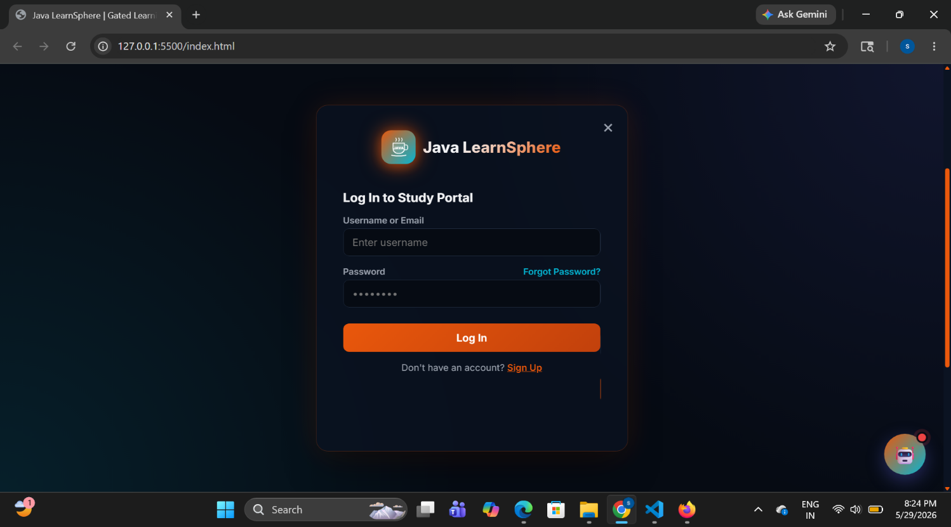

The Login Page serves as the entry point of the Java LearnSphere application. It allows registered users to access the platform by entering their email address and password. The system validates the entered credentials and grants access to authorized users. This page ensures secure authentication and protects user-specific learning data. The simple and responsive design makes the login process easy and user-friendly.

9.3 Registration page :
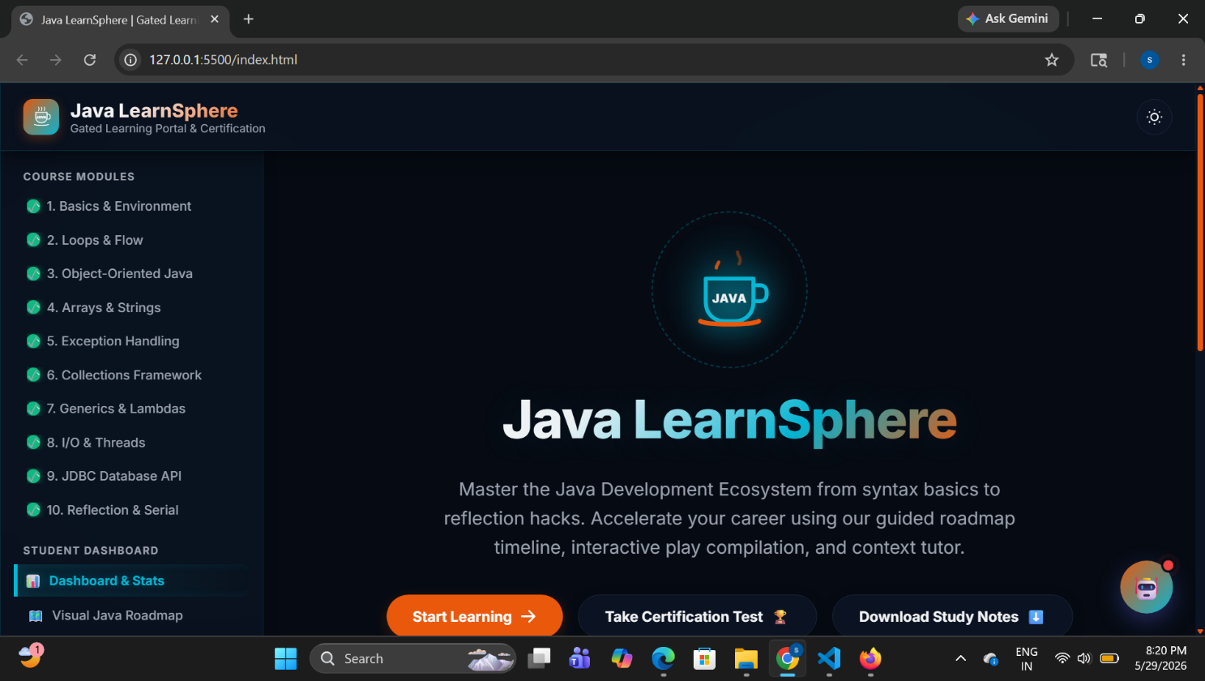
The Registration Page enables new users to create an account on the platform. Users are required to enter their personal details such as username, email address, and password. After successful registration, the user information is stored and can be used for future login. This module helps in maintaining personalized learning records and progress tracking.
9.4 Dashboard :
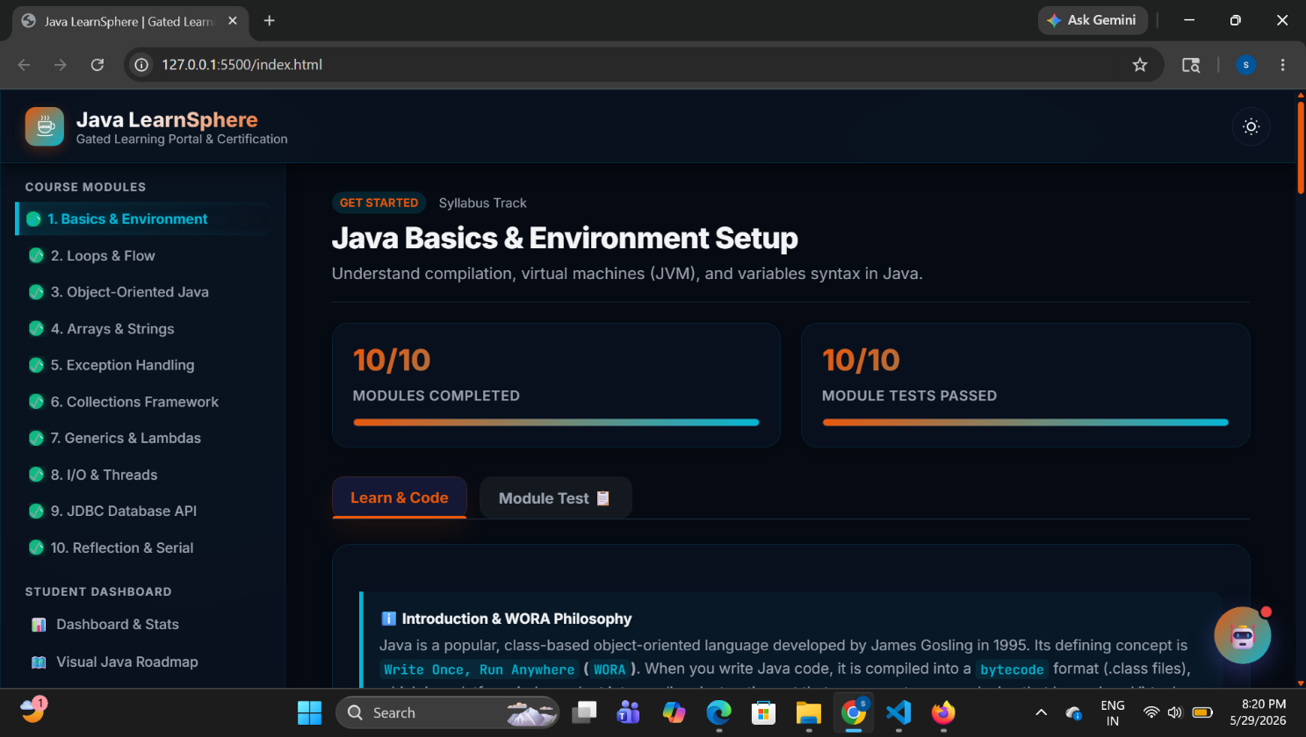

The Dashboard acts as the central control panel of the Java LearnSphere application. It provides quick access to all major functionalities including learning modules, coding playground, quizzes, notes management, progress tracking, AI study companion, and certificate generation. The dashboard also displays user progress and important notifications, helping learners navigate the platform efficiently.

9.5 Learning Module Page :

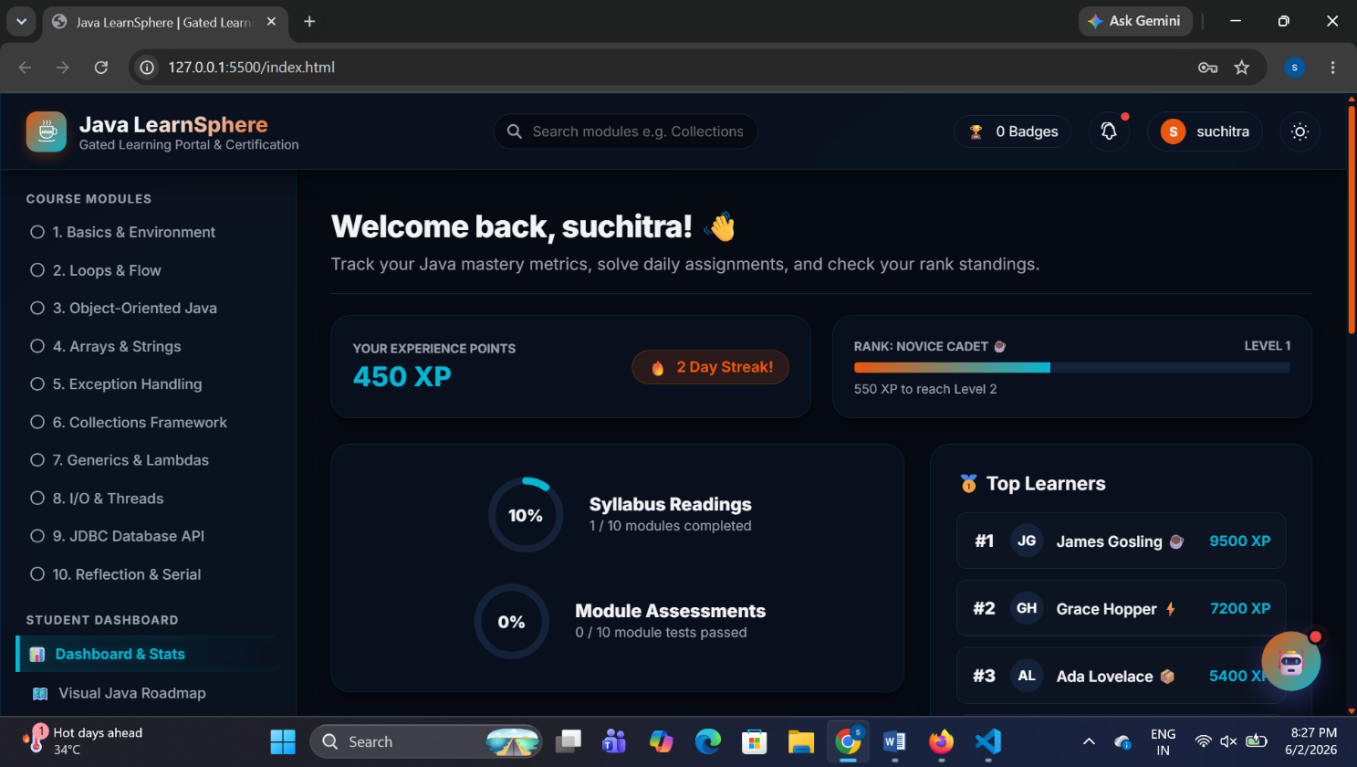

The Learning Module Page contains structured Java programming content organized into various topics and lessons. Users can learn concepts such as variables, operators, loops, arrays, classes, and object-oriented programming principles. The content is presented in a clear and easy-to-understand format, enabling learners to study at their own pace.

9.5 Coding Playground :
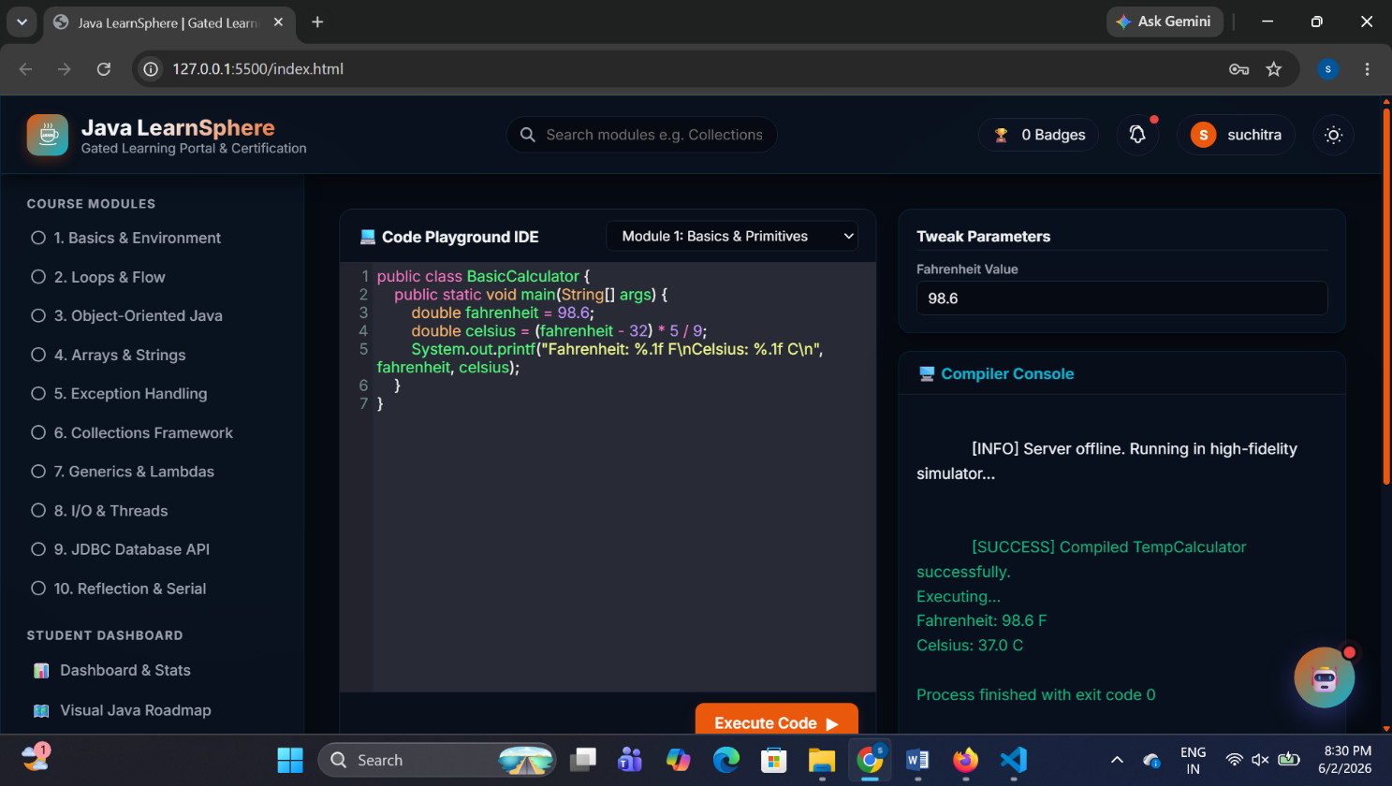
The Coding Playground provides an interactive environment where users can practice Java programming. It includes a code editor with syntax highlighting and formatting support, making coding easier and more efficient. This module encourages practical learning by allowing students to write and experiment with Java code directly within the platform.
9.6 Quiz and Assesment page :
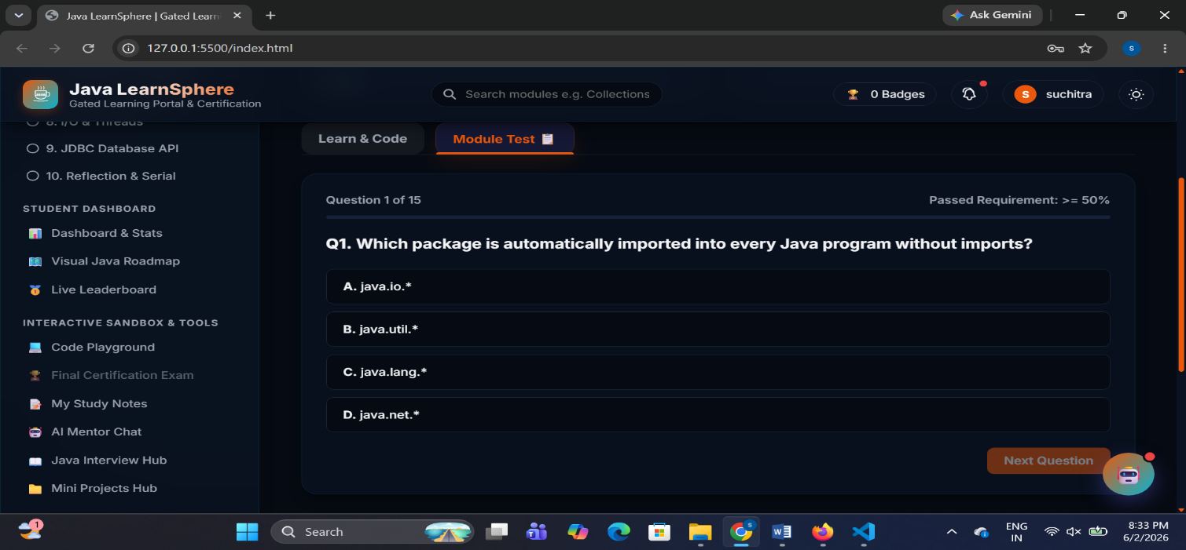
The Quiz and Assessment Page is designed to evaluate the learner’s understanding of Java concepts. It presents multiple-choice questions based on the topics studied by the user. After submission, the system automatically calculates the score and displays the result. This module helps learners identify their strengths and areas for improvement.
9.7 Notes Management Page :
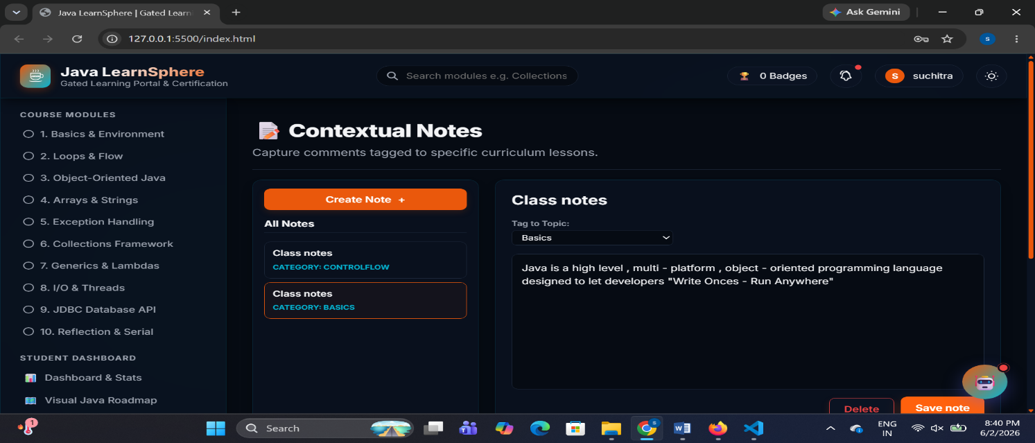
The Notes Management Page allows learners to create, edit, save, and manage personal study notes. Users can record important concepts, code snippets, and revision points for future reference. The notes are stored locally and can be accessed whenever needed, helping learners organize their study materials effectively.
9.8 AI Study Campanion :
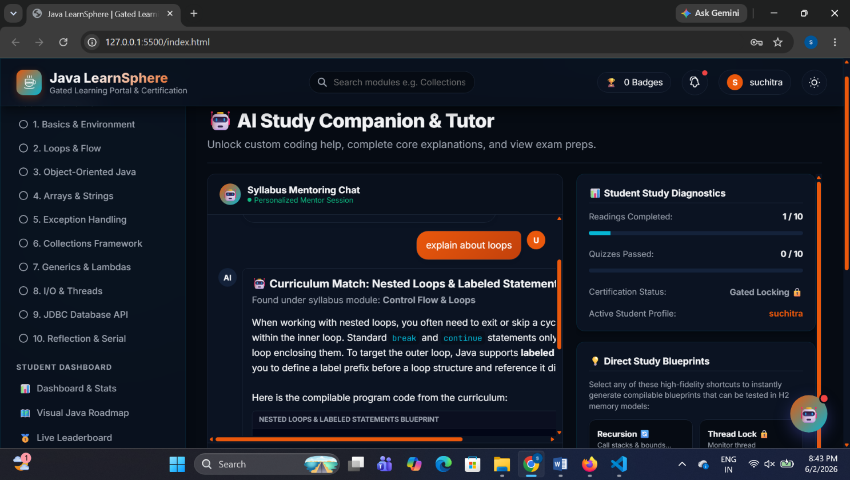
The AI Study Companion provides educational assistance and learning support to users. It helps learners understand programming concepts, provides guidance, and answers study-related questions. This feature enhances the overall learning experience by offering instant support during the learning process.
9.9 Certificate Generation Page :
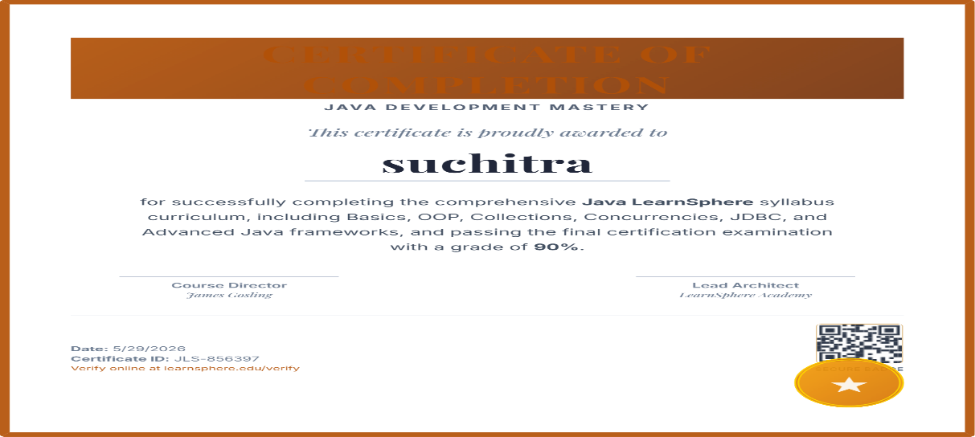
The Certificate Generation Page allows users to obtain a completion certificate after successfully finishing the course requirements. The generated certificate contains the learner’s name, course title, and completion date. This feature recognizes user achievements and serves as proof of successful course completion.
9.10 Java Interview Questions Page :
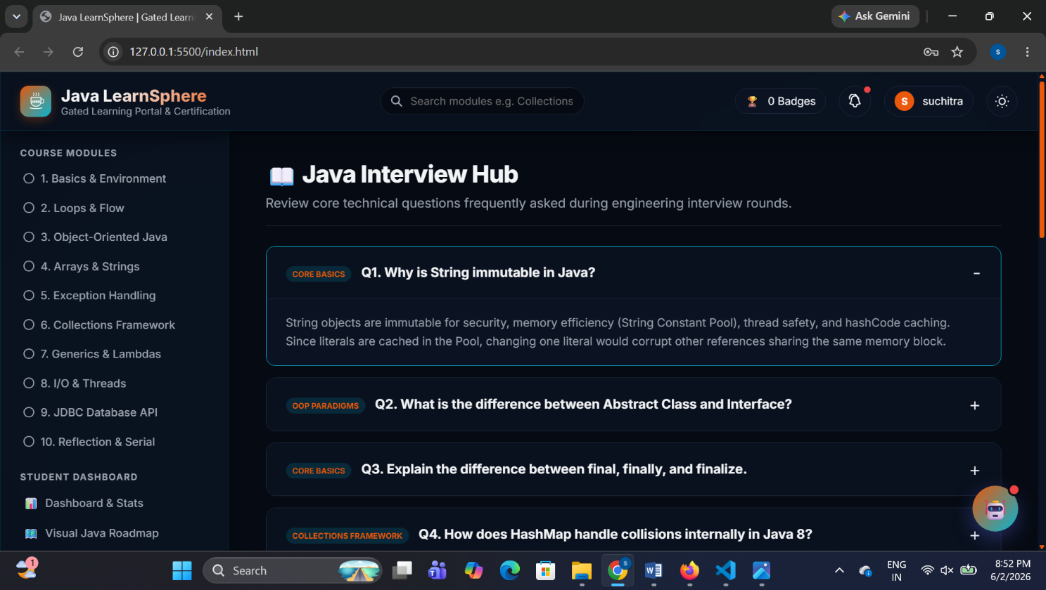
The Java Interview Questions Page is designed to help learners prepare for technical interviews by providing a collection of frequently asked Java interview questions and answers. The page covers fundamental and advanced Java concepts such as Object-Oriented Programming (OOP), Exception Handling, Collections Framework, Multithreading, JDBC, and Java Virtual Machine (JVM). Users can browse questions topic-wise and improve their understanding of important concepts commonly asked in job interviews. This module enhances learners' confidence, strengthens their technical knowledge, and supports career preparation by offering a structured interview preparation resource within the platform.
9.11 Mini Projects Hub Page :
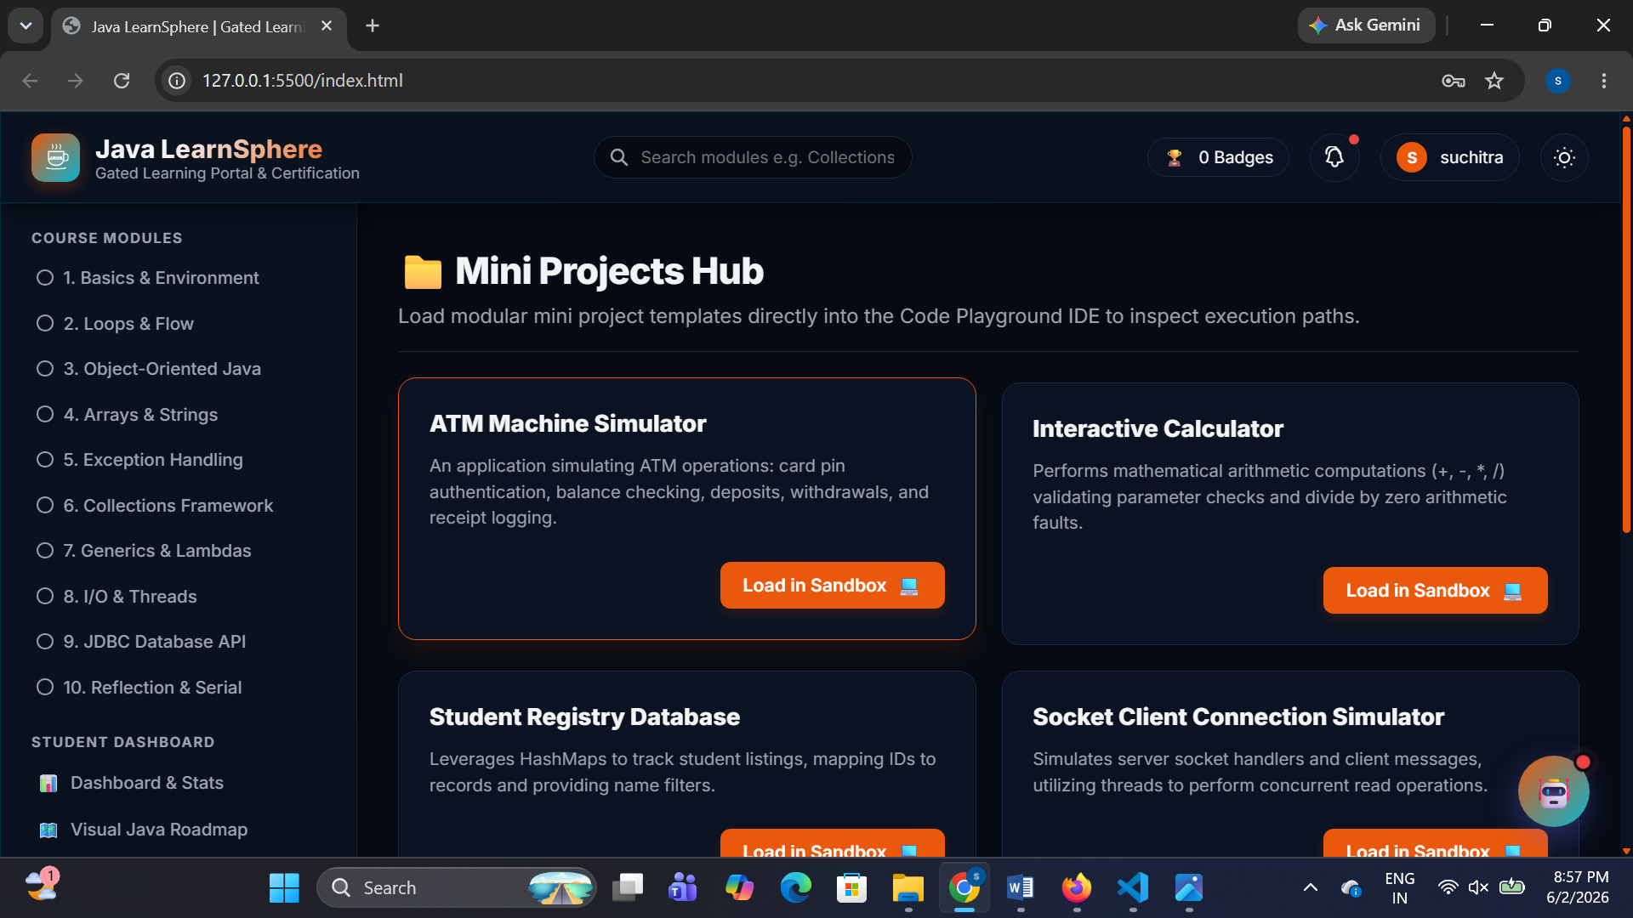
The Mini Projects Page provides learners with practical project ideas and implementations based on Java programming concepts. This page contains a collection of beginner-friendly and intermediate-level mini projects that help users apply their theoretical knowledge in real-world scenarios. Projects such as Student Management System, Library Management System, Calculator Application, Banking System, Quiz Application, and Attendance Management System are included. Each project includes a brief description, objectives, and key functionalities to guide learners through the development process. This module enhances problem-solving skills, promotes hands-on learning, and helps students gain practical experience in software development using Java.

10. IMPLEMENTATION DETAILS

10.1 Introduction :
The implementation phase involves converting the system design into a functional web application. Java LearnSphere was developed using HTML, CSS, and JavaScript to provide an interactive platform for learning Java programming. The system integrates various modules such as authentication, learning content, quizzes, coding practice, progress tracking, and certificate generation.

10.2 Frontend Implementation :
The user interface was developed using HTML5 and CSS3. HTML provides the structure of web pages, while CSS is used for styling, responsive layouts, and theme management. JavaScript adds interactivity and dynamic functionality to the application.

10.3 Authentication Module :
The Authentication Module handles user registration and login processes. User information is validated and stored using browser Local Storage, allowing secure access to personalized learning features.

10.4 Learning Module :
The Learning Module provides structured Java programming lessons. Users can access different topics, read learning materials, and track their completion status.

10.5 Coding Playground :
The Coding Playground enables users to write and practice Java code in an interactive editor. Syntax highlighting is provided to improve coding readability and learning experience.

10.6 Quiz Module :
The Quiz Module allows learners to assess their knowledge through multiple-choice questions. Scores are calculated automatically and displayed immediately after submission.

10.7 Notes Management :
The Notes Module enables users to create, edit, and save personal study notes. Notes are stored locally and can be accessed whenever required.

10.8 Progress Tracking :
The Progress Tracking Module records completed lessons and quiz scores. It helps users monitor their learning progress and achievements.

10.9 Certificate Generation :
After successful course completion, the system generates a personalized certificate containing the learner's details and completion information.

11. TESTING

11.1 Introduction
Testing is an important phase in software development that ensures the system functions correctly and meets user requirements. The Java LearnSphere application was tested to verify the performance, reliability, usability, and accuracy of all modules. Testing helped identify and eliminate errors, ensuring that the system operates smoothly and efficiently.

11.2 Objectives of Testing
The objectives of testing are:
- To verify that all modules function correctly.
- To identify and fix errors and bugs.
- To ensure system reliability and stability.
- To validate user inputs and outputs.
- To improve the overall user experience.

11.3 Types of Testing Performed

Unit Testing :
Unit testing was performed on individual modules such as Login, Registration, Quiz, Notes Management, and Certificate Generation. Each module was tested independently to ensure proper functionality.
Integration Testing :
Integration testing was conducted to verify communication between modules. The interaction between Login, Dashboard, Learning Module, Quiz Module, and Progress Tracking was tested successfully.

Functional Testing :
Functional testing ensured that all features worked according to the system requirements. User registration, login, learning content access, quiz submission, and certificate generation were verified.
User Interface Testing :
The user interface was tested to ensure proper navigation, responsive design, readability, and ease of use across different screen sizes.

Browser Compatibility Testing :
The application was tested on Google Chrome, Mozilla Firefox, and Microsoft Edge to ensure consistent performance across browsers.

11.4 Test Cases
Test Case | Expected Result | Status
User Registration | Account created successfully | Pass
User Login | User redirected to dashboard | Pass
Access Learning Module | Learning content displayed | Pass
Quiz Submission | Score calculated correctly | Pass
Save Notes | Notes stored successfully | Pass
Generate Certificate | Certificate generated successfully | Pass

11.5 Testing Results
The testing process confirmed that all modules function correctly and meet the specified requirements. User authentication, learning modules, coding playground, quizzes, notes management, progress tracking, and certificate generation operated successfully without major issues.

12 SAMPLE CODE :
<!DOCTYPE html>
<html lang="en">
<head>
<meta charset="UTF-8">
<meta name="viewport" content="width=device-width, initial-scale=1.0">
<title>Java LearnSphere | Gated Learning Portal & Certification</title>

<!-- Fonts -->
<link rel="preconnect" href="https://fonts.googleapis.com">
<link rel="preconnect" href="https://fonts.gstatic.com" crossorigin>
<link href="https://fonts.googleapis.com/css2?family=Inter:wght@300;400;500;600;700;800&family=JetBrains+Mono:wght@400;500;600;700&family=Playfair+Display:ital,wght@0,600;0,700;1,500&display=swap" rel="stylesheet">

<!-- CodeMirror (VS Code Style Editor) -->
<link rel="stylesheet" href="https://cdnjs.cloudflare.com/ajax/libs/codemirror/5.65.12/codemirror.min.css">
<link rel="stylesheet" href="https://cdnjs.cloudflare.com/ajax/libs/codemirror/5.65.12/theme/dracula.min.css">
<script src="https://cdnjs.cloudflare.com/ajax/libs/codemirror/5.65.12/codemirror.min.js"></script>
<script src="https://cdnjs.cloudflare.com/ajax/libs/codemirror/5.65.12/mode/clike/clike.min.js"></script>

<!-- Canvas Confetti -->
<script src="https://cdn.jsdelivr.net/npm/canvas-confetti@1.6.0/dist/confetti.browser.min.js"></script>

<!-- html2canvas for Certificate Download -->
<script src="https://cdnjs.cloudflare.com/ajax/libs/html2canvas/1.4.1/html2canvas.min.js"></script>

<style>
/* CSS VARIABLES - THEME SYSTEM */
:root {
--bg-primary: #060b13;
--bg-secondary: #0b1322;
--bg-tertiary: #14223a;
--text-primary: #f3f4f6;
--text-secondary: #9ca3af;
--primary: #ea580c;
--primary-hover: #c2410c;
--primary-rgb: 234, 88, 12;
--secondary: #06b6d4;
--secondary-rgb: 6, 182, 212;
--neon-blue: #3b82f6;
--neon-blue-rgb: 59, 130, 246;
--border-color: #1e293b;
--card-bg: #0b1322;
--code-bg: #05080e;
--input-bg: #060b13;
--success: #10b981;
--error: #ef4444;
--badge-bg: rgba(6, 182, 212, 0.15);
--shadow-sm: 0 1px 2px 0 rgba(0, 0, 0, 0.1);
--shadow-md: 0 4px 6px -1px rgba(0, 0, 0, 0.2), 0 2px 4px -2px rgba(0, 0, 0, 0.2);
--shadow-lg: 0 10px 15px -3px rgba(0, 0, 0, 0.4), 0 4px 6px -4px rgba(0, 0, 0, 0.4);
--glass-bg: rgba(11, 19, 34, 0.75);
--glass-border: rgba(6, 182, 212, 0.15);
--glass-blur: 16px;
}

body.light-theme {
--bg-primary: #f8fafc;
--bg-secondary: #f1f5f9;
--bg-tertiary: #e2e8f0;
--text-primary: #0f172a;
--text-secondary: #475569;
--primary: #ea580c;
--primary-hover: #c2410c;
--primary-rgb: 234, 88, 12;
--secondary: #0891b2;
--secondary-rgb: 8, 145, 178;
--neon-blue: #2563eb;
--neon-blue-rgb: 37, 99, 235;
--border-color: #cbd5e1;
--card-bg: #ffffff;
--code-bg: #f1f5f9;
--input-bg: #f8fafc;
--success: #059669;
--error: #dc2626;
--badge-bg: rgba(8, 145, 178, 0.1);
--shadow-sm: 0 1px 2px 0 rgba(0, 0, 0, 0.02);
--shadow-md: 0 4px 6px -1px rgba(0, 0, 0, 0.05), 0 2px 4px -2px rgba(0, 0, 0, 0.05);
--shadow-lg: 0 10px 15px -3px rgba(0, 0, 0, 0.05), 0 4px 6px -4px rgba(0, 0, 0, 0.05);
--glass-bg: rgba(255, 255, 255, 0.85);
--glass-border: rgba(0, 0, 0, 0.08);
}

/* RESET & BASE */
* {
margin: 0;
padding: 0;
box-sizing: border-box;
font-family: 'Inter', sans-serif;
scrollbar-width: thin;
scrollbar-color: var(--primary) var(--bg-secondary);
}

body {
background: var(--bg-primary);
color: var(--text-primary);
min-height: 100vh;
display: flex;
flex-direction: column;
transition: background-color 0.3s ease, color 0.3s ease;
overflow-x: hidden;
}

/* AUTHENTICATION GATE */
.auth-overlay {
position: fixed;
inset: 0;
background: radial-gradient(circle at top right, rgba(99, 102, 241, 0.12), transparent 45%),
radial-gradient(circle at bottom left, rgba(6, 182, 212, 0.12), transparent 45%),
var(--bg-primary);
display: flex;
align-items: center;
justify-content: center;
z-index: 1000;
padding: 20px;
transition: opacity 0.3s ease, visibility 0.3s;
}

.auth-overlay.hidden {
opacity: 0;
visibility: hidden;
pointer-events: none;
}

.auth-card {
background: var(--glass-bg);
backdrop-filter: blur(var(--glass-blur));
-webkit-backdrop-filter: blur(var(--glass-blur));
border: 1px solid var(--glass-border);
border-radius: 16px;
width: 100%;
max-width: 420px;
padding: 36px;
box-shadow: var(--shadow-lg);
}

.auth-logo {
display: flex;
justify-content: center;
align-items: center;
gap: 12px;
margin-bottom: 20px;
}

.auth-logo-icon {
background: linear-gradient(135deg, var(--primary), var(--secondary));
width: 42px;
height: 42px;
border-radius: 12px;
display: flex;
align-items: center;
justify-content: center;
color: white;
font-size: 1.3rem;
box-shadow: 0 4px 12px rgba(var(--primary-rgb), 0.3);
}

.auth-logo-text h2 {
font-size: 1.3rem;
font-weight: 800;
background: linear-gradient(135deg, var(--text-primary) 30%, var(--primary));
background-clip: text;
-webkit-background-clip: text;
-webkit-text-fill-color: transparent;
}

.auth-form-wrapper {
display: flex;
width: 300%;
transition: transform 0.4s cubic-bezier(0.4, 0, 0.2, 1);
}

.auth-form {
width: 33.333%;
display: flex;
flex-direction: column;
gap: 14px;
}

.auth-title {
font-size: 1.05rem;
font-weight: 700;
}

.input-group {
display: flex;
flex-direction: column;
gap: 4px;
}

.input-group label {
font-size: 0.75rem;
font-weight: 600;
color: var(--text-secondary);
}

.auth-input {
width: 100%;
padding: 10px 12px;
border-radius: 8px;
border: 1px solid var(--border-color);
background: var(--input-bg);
color: var(--text-primary);
font-size: 0.85rem;
outline: none;
transition: all 0.2s;
}

.auth-input:focus {
border-color: var(--primary);
box-shadow: 0 0 0 3px rgba(var(--primary-rgb), 0.12);
}

.auth-btn {
background: linear-gradient(135deg, var(--primary), var(--primary-hover));
color: white;
border: none;
padding: 11px;
border-radius: 8px;
font-weight: 600;
font-size: 0.88rem;
cursor: pointer;
margin-top: 8px;
transition: all 0.2s;
}

.auth-btn:hover {
transform: translateY(-1px);
box-shadow: 0 4px 10px rgba(var(--primary-rgb), 0.2);
}

.auth-switch {
text-align: center;
font-size: 0.78rem;
color: var(--text-secondary);
}

13. RESULTS AND OUTPUTS

13.1 Introduction
The Java LearnSphere application was successfully implemented and tested. All modules functioned according to the specified requirements and provided an effective learning environment for users.

13.2 Authentication Module Result
The Authentication Module successfully handled user registration and login operations, ensuring secure access to the system.

13.3 Learning Module Result
The Learning Module displayed Java programming content successfully and helped users learn concepts in a structured manner.

13.4 Java Interview Questions Result
The Interview Questions module provided important Java interview questions and answers for placement preparation.

13.5 Mini Projects Result
The Mini Projects module offered practical project examples that enhanced users' programming and problem-solving skills.

13.6 Quiz Module Result
The Quiz Module evaluated user performance accurately and generated scores automatically.

13.7 Notes Management Result
The Notes Module allowed users to create and save personal study notes for future reference.

13.8 Progress Tracking Result
The Progress Tracking Module successfully monitored lesson completion and quiz performance.

13.9 Certificate Generation Result
The Certificate Module generated certificates successfully after course completion.

13.10 Overall Result
The Java LearnSphere platform successfully achieved its objectives by providing learning content, coding practice, assessments, progress tracking, and certification within a single application

14 ADVANTAGES & LIMITATIONS OF THE SYSTEM :

14.1 Advantages Of The System :
- User-Friendly Interface
The system provides a simple and easy-to-use interface for learners.
- Interactive Learning
Users can learn Java concepts through structured lessons, quizzes, and coding practice.
- Interview Preparation
Includes Java interview questions to help students prepare for placements and technical interviews.
- Mini Projects Support
Provides mini project ideas and examples for practical learning.
- Progress Tracking
Allows users to monitor their learning progress and achievements.
- Certificate Generation
Generates certificates upon successful course completion.
- Theme Support
Offers both Light and Dark themes for a better user experience.
14.2 Limitations Of The System :
- No Real-Time Code Execution
Users can write code but cannot execute Java programs directly within the platform.
- Local Storage Dependency
User data is stored in browser Local Storage, which may be lost if browser data is cleared.
- Limited Course Content
The platform currently focuses only on Java programming.
- No Cloud Storage
Learning progress cannot be synchronized across multiple devices.
- Basic Security Features
Advanced security mechanisms such as two-factor authentication are not implemented.
- No Mobile Application
The system is available only as a web application.
- Limited AI Functionality
The AI Study Companion provides basic assistance and does not support advanced tutoring features.

15. FUTURE ENHANCEMENTS
- Online Java Compiler Integration
Future versions can include a real-time Java compiler to allow users to write, compile, and execute Java programs directly within the platform.
- Database Integration
A centralized database such as MySQL or MongoDB can be implemented to store user data securely and efficiently.
- Cloud Synchronization
User progress, notes, and certificates can be synchronized across multiple devices using cloud storage.
- Mobile Application Development
Dedicated Android and iOS applications can be developed to improve accessibility and user convenience.
- Advanced AI Learning Assistant
The AI Study Companion can be enhanced to provide personalized learning recommendations and intelligent doubt clarification.
- Additional Programming Courses
Support for other programming languages such as Python, C, C++, and JavaScript can be added.
- Admin and Instructor Module
Separate dashboards for administrators and instructors can be introduced to manage users, content, and assessments.
- Gamification Features
Features such as badges, leaderboards, rewards, and achievements can be added to increase learner engagement.
- Video Tutorials Integration
Video-based learning materials can be incorporated to improve understanding of programming concepts.
- Advanced Analytics and Reporting
Detailed reports and performance analytics can be provided to help learners track their progress more effectively.

16. CONCLUSION
The Java LearnSphere project was successfully developed as a web-based learning platform designed to help users learn Java programming in an interactive and efficient manner. The system integrates various features such as user authentication, structured learning modules, coding practice, quizzes, Java interview questions, mini projects, notes management, progress tracking, and certificate generation within a single application.
The project was implemented using modern web technologies including HTML, CSS, and JavaScript, providing a responsive and user-friendly interface. The platform enables learners to study Java concepts, assess their knowledge through quizzes, prepare for interviews, and gain practical experience through mini projects. The inclusion of progress tracking and certification features further enhances learner motivation and engagement.
The testing results confirmed that all modules function correctly and meet the specified requirements. The system provides a simple, reliable, and effective learning environment that supports self-paced learning and skill development. Although certain limitations exist, the proposed future enhancements can further improve the functionality and scalability of the platform.
In conclusion, Java LearnSphere successfully achieves its objective of providing a comprehensive Java learning solution and serves as a valuable educational tool for students, beginners, and programming enthusiasts. The project demonstrates the effective use of web technologies in developing modern educational applications and contributes to improving the learning experience for Java programming.

17. REFERENCES

- Herbert Schildt, Java: The Complete Reference, McGraw-Hill Education.
- Kathy Sierra and Bert Bates, Head First Java, O'Reilly Media.
- Cay S. Horstmann, Core Java Volume I – Fundamentals, Pearson Education.
- Roger S. Pressman and Bruce R. Maxim, Software Engineering: A Practitioner's Approach, McGraw-Hill Education.
- Ian Sommerville, Software Engineering, Pearson Education.
- HTML5 Documentation, World Wide Web Consortium (W3C).
- CSS3 Documentation, World Wide Web Consortium (W3C).
- JavaScript Documentation, Mozilla Developer Network (MDN).
- Java Platform Documentation, Oracle Corporation.
- CodeMirror Documentation and User Guide.
- HTML2Canvas Documentation and User Manual.
12. Research Papers and Journals on E-Learning Systems, Web-Based Learning Platforms, and Programming Education.

